**EXP8-SOCKET PROGRAMMING-1**

**K. Priya (4600)**

**Introduction to Socket Programming:**

**SERVER PROGRAM:**

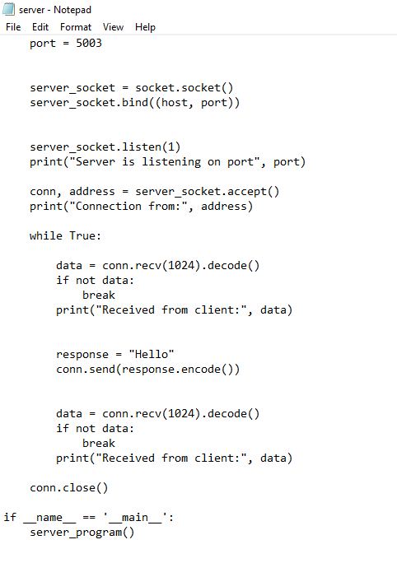

**CLIENT PROGRAM:**

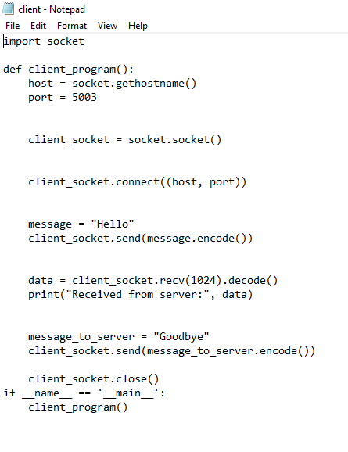

**­OUTPUT: Server Side**

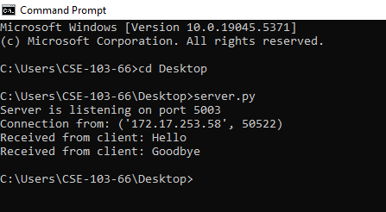

**­OUTPUT: Client Side**

